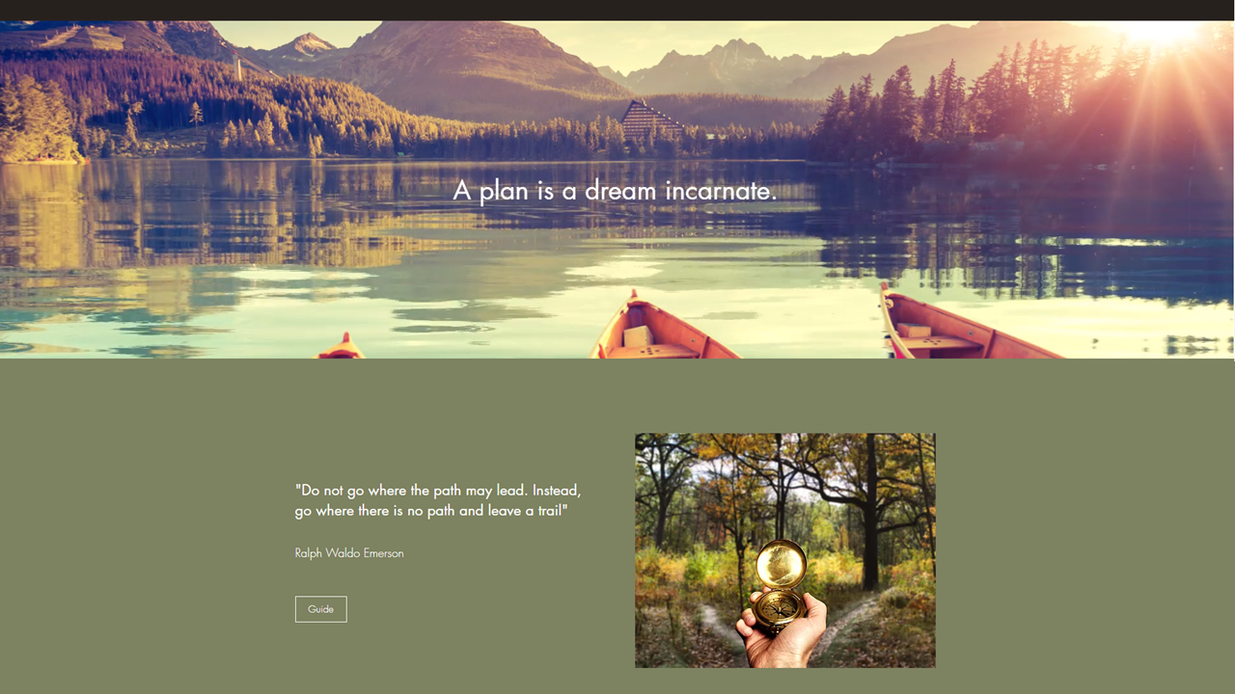

Introduction
Write an introduction (consider using multimodal elements – pictures, poems, hyperlinks, embedded media) that describes how you will invite, excite and capture the curiosity of your students to engage in the unit.
Be creative – think of an experience that will engage your students making connections to course content:
- Tony Wagner’s concept of “passion, purpose and play”
- Readings and viewings related to providing authentic and agentic experiences
- Consider intrinsic motivation – autonomy, mastery, purpose
Some ideas include:  - An excursion (Think creatively beyond some of the usual field trip locations. For example, have you looked at all of the innovative outreach opportunities provided by various levels of government and community organisations? Public parks, courthouses, Galleries. Museums, radio/tv station, conservatories, town planning offices, botanical gardens, design institutes, wetlands, ,media studios, council chambers, Aboriginal Corporations, Land and Sea Rangers, Environmental Education Centres, research labs, earth stations, JCU – Orpheus Island, Daintree Observatory, Outback Station, Research Institutes and labs);  - Performance (For example put on by a local High School, amateur or professional);  - A community event or festival (or school fete, NAIDOC, Under 8s Day);  - Class/Year level based special event (Carnival, Game Show, Design Sprint – like they do in Master Chef for example);  - Guest speakers or incursion (like Questacon, Mixhaus);  - Story and Conceptual Playworld (see free Fleer Conceptual Playworld App). | 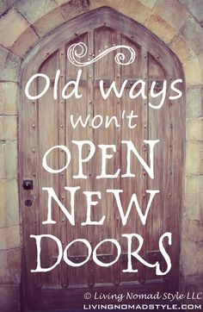

NOTE: You don’t have to include practical planning considerations (This isn’t the lesson plan), connect it to the curriculum or discuss how you might use this experience as diagnostic assessment to inform future planning.
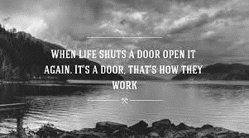
Consider Using Pictures to enhance your introduction

Identify curriculum
Ways of working – Process and Production Skills | Knowledge and understanding Content Descriptors
Hint: Insert Content Descriptors Process and Production Skills strand of the Australian Curriculum: Technologies manually if you are not using Quinking TM software which will prepopulate this for you in the Planning/Trekking Toolkit TM. | Hint: Insert Content Descriptors Knowledge and Understanding strand of the Australian Curriculum: Technologies manually if you are not using Quinking TM software which will prepopulate this for you in the Planning/Trekking Toolkit TM.
Context for learning | School priorities
Hint: Describe the specific context for learning that you have designed, considering:  - Is it an authentic experience with opportunities for play and agency?  - Is it relevant and connected to the interests of the students?  - Is it intrinsically motivating (autonomy, mastery, purpose)?  - Will students be engaged in design thinking, computational thinking and/or systems thinking? | Hint: Insert School Priorities from your Annual Implementation Plan manually if you are not using Quinking TM software which will prepopulate this for you in the Planning/Trekking Toolkit TM.

B. Unit Planner

Develop assessment |  |  | Make judgments
Type of assessment | What will be assessed | When it will be assessed | Purpose of assessment | Assessable elements
Hint: Insert details manually if you are not using Quinking TM software which will prepopulate this for you from the planning/trekking tool.  Diagnostic Assessment: Find out what students already know and can do to adjust planning to meet student needs.  Formative Assessment: Supporting students to use feedback to plan the next steps for learning.  Summative Assessment: Collecting evidence of student achievement against standards for reporting.  HINT: Use hyperlinks to show examples of the type of assessment artefacts you planned on using. | Evidence of what students know and can do against the subject’s specific Achievement Standards  Students reflect on and monitor their own progress to inform their future learning goals:  Evidence of what students know and can do against the relevant Achievement Standards  . | Before (during unit planning stage) or at the beginning of a unit.  Throughout the unit. Can involve an instructional routine (exit pass) where students reflect on feedback  This can be done progressively throughout a unit (a portfolio approach) or at the end of a unit (completion of a project or design brief). | Make decisions about or changes to planned teaching and learning experiences to make sure it meets students at their point of need.  Build self-efficacy in students and promote intrinsic motivation. Can inform future teaching – how will the unit sequence or lessons planned need to be adjusted to deliver “Just in time” learning.  Teachers use evidence of student learning to assess student achievement against Achievement Standards to plan future learning, evaluate teaching impact, identify opportunities for intervention and extension & reporting. | APPLIES TO ALL 3 TYPES OF ASSESSMENT  Hint: What parts of the evidence that you collect will you be assessing?  What are the knowledges and skills that you will be assessing and how are they specifically connected to the Achievement Standards For example, to evaluate student achievement in technologies, you would not look at spelling as an indicator of achievement.  HINT: Check out the ACARA endorsed Work Samples for ideas.
Sequence learning
Learning experiences and teaching strategies | Adjustments for needs of learners | Resources
Hint: Insert details manually if you are not using Quinking TM software which will prepopulate this for you from the planning/trekking tool.  Include a brief description as you will be going into more detail in the lesson plan. | Describe how you will adjust the:  - Physical environment  - Socio-Cultural Environment  - Curriculum – see examples below.  Curriculum Examples include:  - Pre-teaching skills and knowledge students need  - Extending to next band level  - Use of scaffolding like graphic organisers, visual (picture) cues, displays  - Individual goal setting  - Choice of how students demonstrate their learning  - Multi-level groups where each member has a specific role and part of the overall project that relates specifically to the content descriptors they need to master (i.e. teleportation design brief)  - Different resources – for example, use a Hello Ruby type task that could be used with a different text (i.e. Where the Wild Things Are) | Hints:  This part of the process involves identifying the availability of environments (specific location offsite for excursion or at school could be the technologies lab) equipment and resources. Resources may refer to human resources as well as materials and equipment.
Use feedback
Ways to monitor learning and assessment
Hints:
How will you monitor learning throughout the unit? Ideas include:
- Every lesson will have a clear learning outcome and success criteria the students refer to and at the end of the lesson self-evaluate or peer evaluate and report their learning and feedback in a variety of ways (exit passes: 2 stars and a wish; traffic lights)
- You could use a kaban board or GANTT Chart
- Take pictures and annotate them or video recordings of students either engaging in the task or short interviews with students where you give feedback
Feedback – think of Austin’s Butterfly. Think: Is feedback specific, relevant, helpful, invited?

TEMPLATE A: Explicit Teaching
Lesson Intent (WALT) | What content are your students learning and why is it important?
Success Criteria (WILL) | What skills will be developed and what does success look like (for self/peer evaluation)?

Time | Leading Learning | Project Management
5 min  I DO  5- 10 min  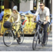  WE DO  5- 15 min  YOU DO  30 min | BEGINNING  Teacher uses play, passion and purpose to entice students into the lesson with a story, stimulus, social or playful invitation that also activates their prior knowledge and stimulates their curiosity for the next stage of learning.  Teacher explains learning intention (WALT) and criteria (WILL). Students connect prior knowledge to WALT, make predications, visualise what success looks like and set goals.  MIDDLE  Teacher models the new skill to students using planned think alouds and age appropriate multi-modals to make learning visible. Students watch the teacher perform the skill and listen to think alouds to understand how the skill is to be performed.  Teacher helps the students to practice the new skill providing targeted and guided support. Students start to practice the skill, asking for help when they need it, trying to move towards less support to independence.  Teacher provides conditions for students to practice towards mastery which includes providing mechanisms (visual displays of success criteria, culture of feedback) for students to self and peer evaluate. Students independently practice the new skill, self and peer evaluate, apply feedback and challenge themselves to improve towards mastery.  CONCLUSION  Teacher consolidates the learning with a reflection activity (2 stars and a wish, traffic lights, thumbs up/down) to check for understanding and lead students in self-evaluation or peer conferencing on the goals they set at the beginning of the session. Students participate in reflection and may also make suggestions, anticipate future problems, request to renegotiate timelines/resources/support. | Include:  Required features of classroom or alternative location (dedicated STEM lab, makey space, performing arts centre, playatorium, nature space, field trip…)  Resources  Student groups and collaboration strategies  Managing time and transitions

ASSESSMENT AND REFLECTION: What artefacts of learning have you collected to assess student understanding of the WALT and WILL? How will you provide feedback? How will you self-reflect and self-evaluate the effectiveness of this lesson? Insert details manually if you are not using Quinking TM software which will prepopulate this for you from the planning/trekking tool.

c. Lesson Plans
TEMPLATE B: Design Sprint
Design Brief: Instructions for a design challenge that include the following elements:
- WHO: Relevant audience the students are designing for.
- WHY: What challenge/opportunity will the designed product/service/environment address?
- WHEN/WHERE/HOW: What are the available resources and restraints?
- WHAT: Specifications to evaluate whether the product/service/environment meets the brief.

Time * | Leading Learning | Project Management
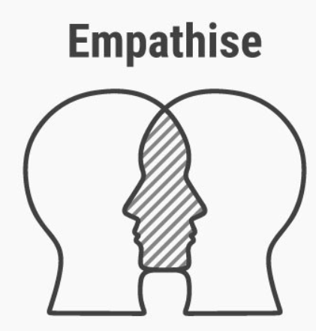  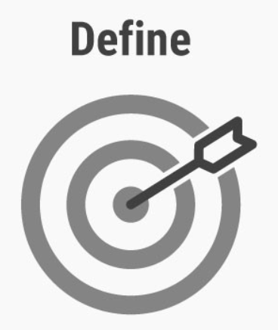  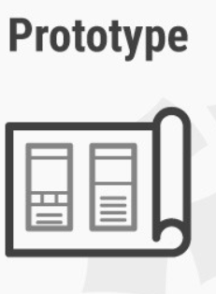 | BEGINNING  Preparations will have been made in advance for the Design Sprint. Welcome and thank visitors, helpers, sponsors and stakeholders. Explain logistics and focus your students’ energy on the design brief.  MIDDLE  Empathise  Students participate in planned activities to learn about their audience. Examples include: focussed interviews, role play simulations, user observations (Young children can benefit from multi-sensory opportunities and record observations through multi-modal or artistic representations)  Define  Teacher plans activities for students to be able to interpret their observations to focus on one very specific problem or opportunity that their audience needs/wants.  Ideate  Teacher plans activities and challenges that will extend students beyond their demonstrated skill level to develop fluency (volume) and flexibility (variety) of innovative options.  Prototype  Depending on resources and constraints, students develop a limited number of prototypes to test their most promising ideas.  Test  Placing low-resolution artefacts (the prototypes) in front of the appropriate context of the user’s (audience’s) life to identify opportunities for improvement.  CONCLUSION  Important features of the design sprint that encourage transfer of learning and personal and social capabilities are publicly presenting, celebrating and reflecting on the experience. | Include:  Required features of classroom or alternative location (dedicated STEM lab, makey space, performing arts centre, playatorium, nature space, field trip…)  Resources  Stakeholders/clients/customers that students are designing for  Additional expertise and helpers – think creatively (maybe you could invite design students from the local high school or future preservice teachers looking for professional experience/volunteer days).  Student groups and collaboration strategies  Managing time and transitions
Some school, class and student details will prepopulate based on your specific class context and will autonomously sync and update with “just in time” relevant adjustments made to lesson plans so they are timely and relevant with Quinking TM software.

ASSESSMENT AND REFLECTION: What artefacts of learning have you collected to assess student understanding of the WALT and WILL? How will you provide feedback? How will you self-reflect and self-evaluate the effectiveness of this lesson? Quinking TM software allows syncing for evidence based decision making, feedback, self/student evaluation and secure sharing/reporting with caregivers/approved stakeholders.

TEMPLATE C: Hybrid of Explicit Thinking and Design Sprint (Managing a BIG EVENT!!)
Design Brief: Instructions for a design challenge that include the following elements:
- WHO: Relevant audience the students are designing for.
- WHY: What challenge/opportunity will the designed product/service/environment address?
- WHEN/WHERE/HOW: What are the available resources and restraints?
- WHAT: Specifications to evaluate whether the product/service/environment meets the brief.

Time | Leading Learning | Project Management
I DO  WE DO  YOU DO | BEGINNING  Make sure you focus specifically on the testing aspect of the lesson and not just describe the event. For example, a party, performance, competition or festival might be part of the celebratory context for the test, but it’s important not to lose sight of the learning.  The lesson part of the event will assemble everyone to focus on the test by explaining the Design Brief: the students could do this – a formative assessment at the Define phase could be the creation of a (digital) artefact for this purpose.  MIDDLE  There will still be an “I do” phase where the teacher explains (timetables, groupings, rules, maps, use of resources, safety protocols) the procedures that will be followed during the testing phase models with think alouds how to trouble shoot common problems.  It’s a good idea to consider how to rehearse a trial run of the test (“we do”) with a walk through or with a dummy or model if feasible. If not a virtual or visualised walk through with prompted questioning (what do we do next, what if this happens) questioning is a good substitute for a “we do”.  Describe the main event. Make it epic.  CONCLUSION  Important features of the design sprint that encourage transfer of learning and personal and social capabilities are publicly presenting, celebrating and reflecting on the experience. | Include:  Required features of classroom or alternative location (dedicated STEM lab, makey space, performing arts centre, playatorium, nature space, field trip…)  Resources  Stakeholders/clients/customers that students are designing for  Additional expertise and helpers – think creatively (maybe you could invite design students from the local high school or future preservice teachers looking for professional experience/volunteer days).  Student groups and collaboration strategies  Managing time and transitions

* Times can vary. A Design Sprint could be a special event taking place over a whole week, a day or a session.

ASSESSMENT AND REFLECTION: What artefacts of learning have you collected to assess student understanding of the WALT and WILL? How will you provide feedback? How will you self-reflect and self-evaluate the effectiveness of this lesson?

D. Critical Reflection
Critically reflect on planning the unit after its conclusion as a team – post mortem
Hint: Think about connecting theory, planning with your observations/data

Did you intrinsically motivate (autonomy, mastery, purpose) students with purpose, passion and play towards enacting their preferred futures with an emphasis on one of the priority areas of:
- Indigenous education (HINT: Isn’t Design Thinking in many ways based on traditional values and ways of knowing/working? What other opportunities are digital technologies creating in Indigenous Education? https://theconversation.com/digital-land-rights-co-designing-technologies-with-indigenous-australians-99751 );

- Education for sustainability (Remember that the concept of sustainability is very broad, and it doesn’t necessarily have to relate to the environment – Sustainability issues include health, finance, wellbeing, time management, equity, opportunity. In theory, you could argue that any design challenge is aimed at sustainability since at it’s core it is about improving the lives of people. You could make the argument that if you are challenging your students to consider a better way of doing something, then the old way of doing it was unsustainable. You could also make the link to the sustainability of our current education model – think Sir Ken Robinson and the New Basics Report.

- Inclusion and community connectedness: Have you planned your unit specifically for your local content? Are there community connections that show how you are applying theory to practice and intentionally planning authentic experiences for our local children and young people?

Did your students demonstrate improvement and achievement against the big ideas of the Technologies Curriculum?

  - Systems Thinking
    - Breaking down problems into their individual components
    - Project management and collaboration (agile)
    - very detailed, sequential and criteria based
  - Computational Thinking
    - Abstraction – Moreover, making abstractions visible
    - Sequencing, iteration, algorithms, branching
    - Move from the body (actions, games, songs) to concrete (blocks, toys, bee-bots), representational (drawings, plans, pictures), operational (scratch)
  - Design Thinking
    - Modelling and creating opportunities to develop empathy
    - Creative risk taking and divergent thinking
    - experimentation and playfulness (Hello Ruby) to synthesise creativity and play with the rationality and logic of computational thinking.

E. REFERENCES and ATTACHMENTS

Record your data, artefacts and references (professional and academic literature used to inform planning, teaching and reflection).
This is an important step as it will:
- keep the bar high and make sure that if you use the unit in the future, you can simply do quick update searches on relevant literature to make sure your content is current (science and tech content isn’t outdated);
- assist any teachers you share the unit with to adapt the unit to their context;
- encourage you to publish what you learned throughout this unit which is helpful because you will:
  - receive feedback and likely connect with other likeminded practitioners;
  - grow the evidence base for confident, connected and creative curriculum and child/user experience planning/implementation in public policy;
  - spark creative conversations and promote positivity throughout our profession;
  - inspire more people to wonder and take tiny incremental steps towards their preferred futures which collectively, represents momentous movement.

